**A Project Report on**

# “Pin generating security system (VAULT)”

**Abstract**

This project aims to create a simple, yet effective security solution that is both economical and scalable with features such as cyclic pin generation in every 30 seconds, encryption and an accompanying android application, into a marketable product, making physical keys and the need to remember x number pins redundant, offering enhanced user convenience. The project approach focused on simplicity and functionality, this helped make VAULT what it is, an encrypted pin generating security system that is easy to use and economical to make.

**Hardware, Software and tools used**

**Software**

Arduino Ide: Programming of the uno board

Tinker cad: Mapping components and simulations

Android Studio: Programming the android application

Power point: making presentations

**Hardware**

Arduino uno: main IC

Hc-05 Bluetooth module: Bluetooth transmitter

IIC Lcd display (output): Display element

Key pad (input): input Element

Servo motor: locking and unlocking

External power Supply (9v battery): supply power to all components

Jumper wires: connecting all components

Barrel jack: power supply jack

Bread board: making solderless connections

**Tools**

Multi meter: checking voltages of battery and components

YouTube: know-how information

**Block diagram & Description**

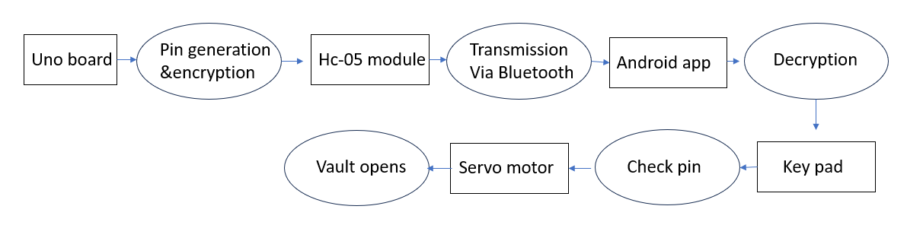

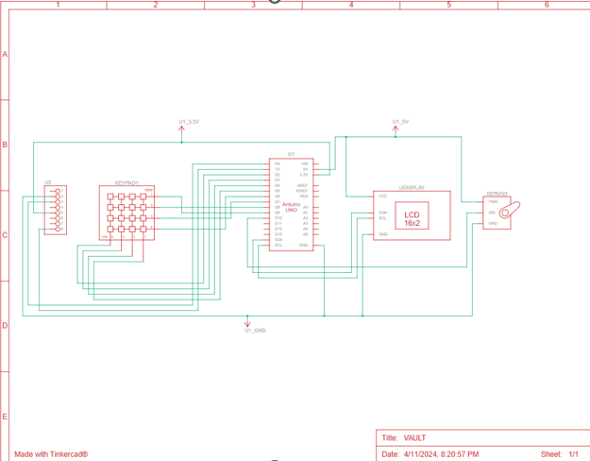

The rectangles represent components and the ovals represent their function.

The process starts at the uno board where a random number generator is seeded with a time function and

Generates the pin which gives the user the access to the vault next that pin is encrypted with a basic ‘EXOR’

And bit rotation operations then the encrypted pin is passed to the HC-05 module for transmission via Bluetooth, the android application then receives the pin, decrypts it and displays it to the user.

When the user enters a valid pin the uno checks it against the generated pin and signals the servo motor to rotate, opening the vault.

A new pin is generated every 30 seconds making the previous pin incorrect, so the user need not worry about potential pin leaks or remembering a x number digit pin that makes no sense.

**Results (Model’s image)**

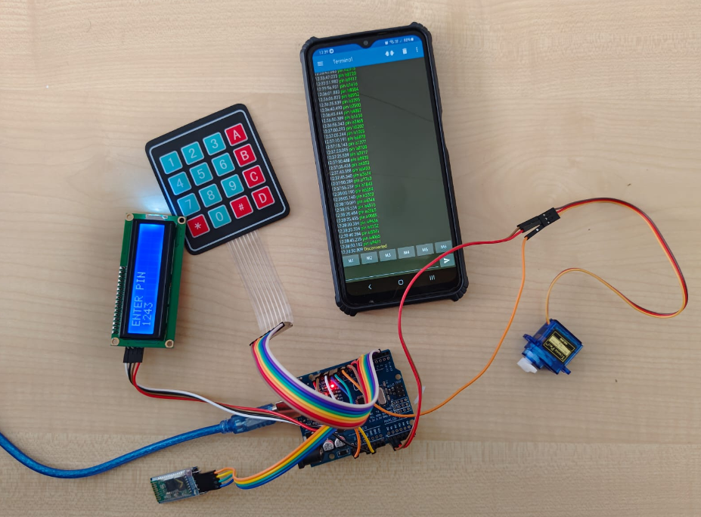

**Challenges faced**

* Finding a suitable environment for android application development.
* Coordinating android application with Bluetooth module.
* Debugging, fail safe ‘Ing.
* Maintaining standard of work.
* Finding a viable encryption option.
* Technical challenges in the algorithm.
* Finding necessary and compatible hardware.
* Coordinating team mates.

**Challenges**

* Optimization of the generation method to be safer using different AES libraries.
* A stronger encryption method as opposed to the basic EXOR and bit rotation.
* Optimization of the application.
* Better/more robust locking mechanism.

**Conclusion**

VAULT is an economical yet effective security solution for domestics, industrial and military needs, VAULT can be employed in various places that need safe keeping like banks, armories and even homes it makes redundant, physical keys and the need to remember an x number pin that make no sense, the project touches upon diverse and vast fields such as encryption, electronics, networks and transmission making the journey challenging yet a fun experience with complementary learning.